Assignment: Use Case, Scenario, & Interaction Design

**Objectives:**

* Practice creating use case models for a real-world software product.
* Practice using Visio to create use case diagrams.
* Practice writing use case description, a.k.a. scenarios.
* Practice using Interaction Design Principles to evaluate a real-world software product.

**Preparation:**

For Windows users, please follow the instructions below and install Visio 2016/2019, and use it to model software processes (in the format of activity diagram).

For Mac users, you may use Omnigraffle if you have it installed already, or you may use any Windows lab machine at Riverside Hall to complete this assignment.

**Visio 2016/2019 Installation:**

Please refer to “*Instructions on how to download Visio 2016.pdf*” posted in the assignment instructions in Canvas.

**Using Visio 2016/2019**

Launch Visio 2016/2019, and you will see the following screen:

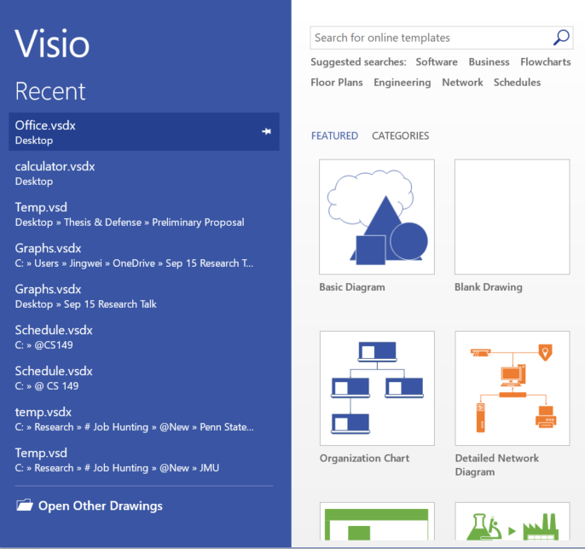 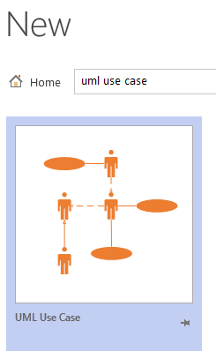 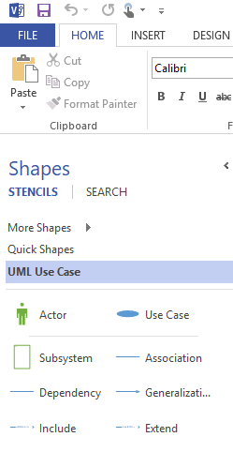

In the top search bar, search for “uml use case”, then you will see the corresponding template. Once you select the template, the basic elements of a use case diagram will be available on the left menu. Note that there may be some missing elements, for example, “other system”. You may search for those elements in Visio, or use basic shapes that are available under tab “Quick Shapes” to represent them.

**Part I: Use Case** (40 pts)

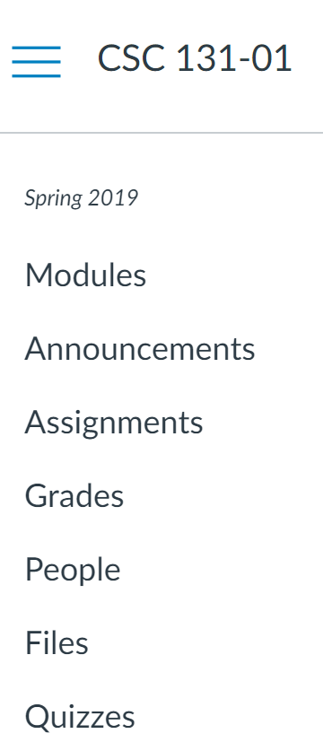Please refer to the use case diagrams of ATM Machine and POS Terminal we learned in class. Create two use case diagrams ***A*** and ***B*** to model Canvas (as the system to be implemented) that satisfy the following requirements:

1. Use one use case diagram ***A*** to model Canvas at the system-level.
2. Use the other use case diagram ***B*** to model the use case “Submit Assignments”.

**Hints**:

* 1. Who is/are the actor(s)?
  2. What can they do? You may refer to the course menu on the right 🡪
  3. Is there any other system involved? If so, what is it?
  4. Use proper links to represent association/dependence.
  5. Do NOT forget to specify multiplicity.

**Part II: Use Case Description – Scenario** (20 pts)

Pick a use case in your use case diagram ***A*** (created in Part I), and make a use case description for it using the template which is given below.

* *Use Case Name*: To identify the use case
* *Actors*: The agents participating in the use case
* *Stakeholders and Needs*: What this use case does to meet stakeholder needs
* *Preconditions*: What must be true before this use case begins
* *Post conditions*: What will be true when this use case ends
* *Trigger*: The event that causes this use case to begin
* *Basic Flow*: The steps in a typical successful instance of this use case
* *Extensions*: The steps in alternative instances of this use case occurring either because of variations in the normal ow or because of errors.

**Part III: Interaction Design Principles** (40 pts)

Please refer to the ***Interaction Design Principles*** we learned in class (**SAC**, **CAP**, **FeVER**). Use them to evaluate the interaction design of Canvas. For each design principle, please give a brief explanation to your evaluation result. Feel free to include screen shots if needed.

Note: This is NOT a usability test yet, but hopefully you can get a little flavor of how to evaluate the UI design of a product.

**SAC:**

**S**implicity:

**A**ccessibility:

**C**onsistency:

**CAP**:

**C**ontrast:

**A**lignment:

**P**roximity:

**FeVER:**

**Fe**edback:

**V**isibility:

**E**rror Prevention:

**R**ecovery: